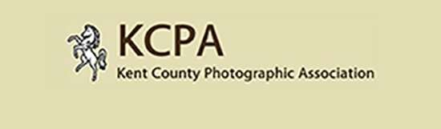

APM Application Form

Details of event –

25th September 2022
@ 9:30 am – 4.30 pm
Cornwallis Academy
Hubbards Lane,
Maidstone. ME17 4HX

Name……………………………………………………………………………………

Email address……………………………………………………………………….

Club name……………………………………………………………………………

Delete as appropriate

Advice wanted for CPAGB / DPAGB / MPAGB Prints or PDI’s

Paying via Cheque or PayPal

Cheques to be payable to KCPA and sent to

Tracy Hughes 6 Cook Close, Lordswood, Chatham, Kent, ME5 8LU.

Ticket wanted Spectator @ £20.00 Ticket wanted Observer@ £10.00

Email form to competitions@kcpa.co.uk

